1.If the Fourier transform of a signal x(t) is X(f), what is the Fourier transform of its time-reversed version x(-t)?

a)X(−f)

b)X(f)

c)X*(f) (complex conjugate)

d)-X(f)

2.A BJT is operating in the saturation region. Which of the following statements is true?

1. Vce is approximately equal to Vbe.
2. Vce is greater than Vbe.
3. The collector current depends upon the base current
4. The transistor behaves as an open switch

3.If a 4-bit synchronous counter is designed using JK flip-flops and an AND gate to reset at 1101 (decimal 13), what will be the next state after 1101?

1. 1110
2. 0000
3. 1111
4. 1000

4.In a common-emitter amplifier, if the collector resistor is increased while keeping all other parameters constant, how does the voltage gain change?

1. Increases
2. Decreases
3. Remains the same
4. Becomes unpredictable

5.In a p-n junction, the depletion layer width:

1. Increases when forward biased
2. Decreases when reverse biased
3. Increases when reverse biased
4. Remains constant regardless of bias

6.A JFET operating in the saturation region has a drain current of 4mA when VGS = -1V. If the pinch-off voltage is -4V and IDSS = 16mA, what is the transconductance (gm) at the operating point?

1. 2 mA/V
2. 3 mA/V
3. 4 mA/V
4. 6 mA/V

7.A discrete-time system is described by y[n] = x[n] - x[n-1] + 0.9y[n-1]. The system is:

1. Stable and causal
2. Unstable and causal
3. Stable and non causal
4. Unstable and non causal

8. The load impedance of a CE amplifier has and in series. The phase difference between output and input will be

a) 180°

b) 0

c)More than 90° but less than 180°

d)More than 180° but less than 270°

9.An amplifier has a large AC input signal. The clipping occurs on both the peaks. The output voltage will be nearly a

a)sine wave

b)square wave

c)triangular wave

d) a or c

10. How many 3-line-to-8-line decoders are required for a 1-of-32 decoder?  
  
(A) 1

(B) 2

(C) 4

(D) 8

11. Which of the following oscillators is suitable for frequencies in the range of megahertz?

(A) RC phase shift

(B) Wien bridge

(C) Hartley

(D) Both (a) and c

12. A heater operates at 220 V and has 99 percent efficiency. Its energy consumption is 1.5 kWhr. What will be the input current of the heater?

a) 22 A

b)6.82 A

c) 2.22 A

d) 7.56 A

13.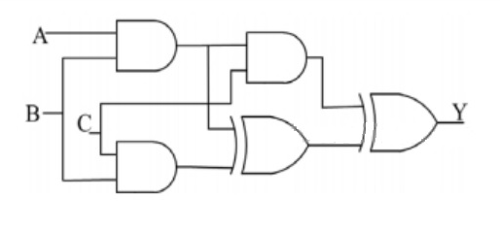

Find the output of the combinational circuit given above

1. AB+B~C+C~A
2. A+B+~C
3. A.B.~C
4. A+BC+C~A  
     
   14. A decade counter requires

a) 4 flip-flops

b) 3 flip-flops

c) 10 flip-flops

d) 2 flip-flops

15) Which of the following is a balance equation for computing the resistance?

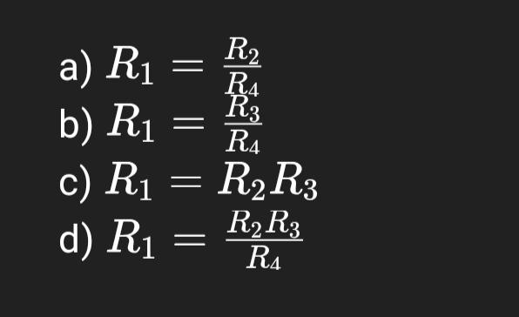

Ans - D

16) ________ is a correct combination for an ODD-parity data transmission system.

a)data = 1101 1011

parity = 1

b)data = 1101 0010

parity = 0

c)data = 0001 0101

parity = 1

d)data = 1010 1111

parity = 0

17) Which of the following semiconductor devices does not have negative resistance characteristics?

a) FET

b)SCR

c)UJT

d) None of the above

18)”The Emitter-Base junction is forward biased for active operations” , this statement is valid for

a)both pnp and npn transistors

b)hetero junction bipolar transistor

c) npn transistor

d) pnp transistor

19)Which of the following losses occurs in the core of a transformer?

a) Copper loss

b) Stray loss

c) **Eddy current loss**

d) Mechanical loss

20) Find the Y – parameter Y21 in the circuit shown below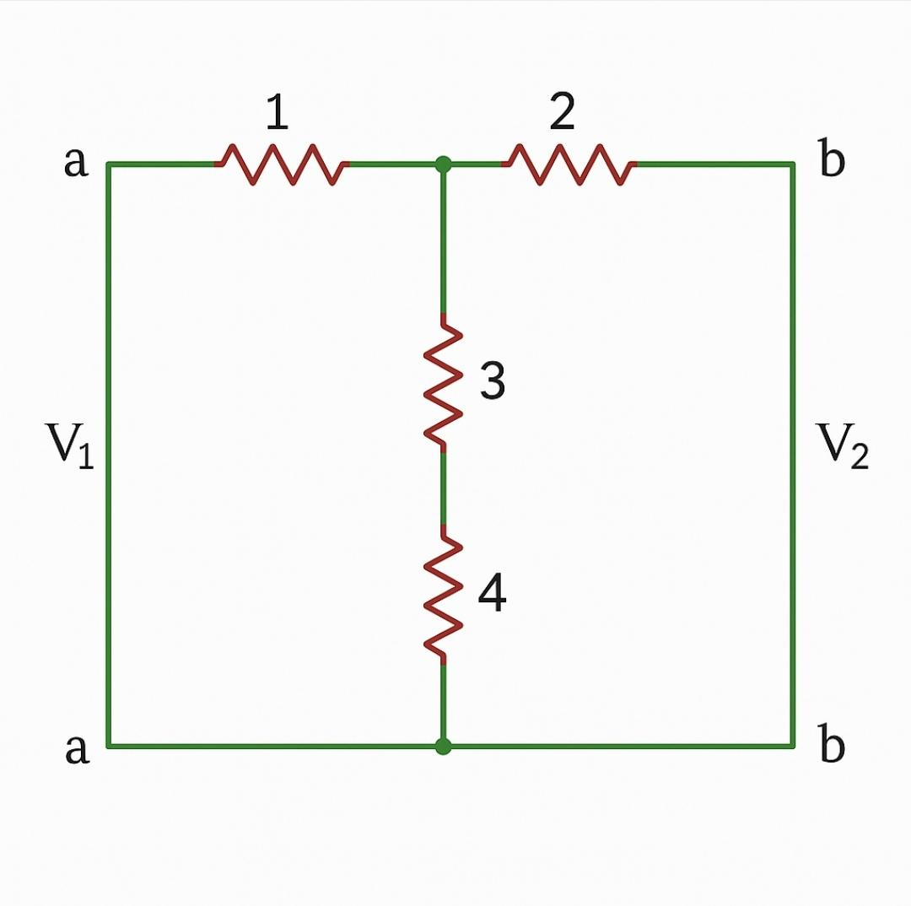

a) -1/4

b) 1/4

c) 1/2

d) -1/2

2-

22)In an 8086 microprocessor system, what is the minimum number of address lines required to access a 64 KB memory bank?

A) 14

B) 15

C) 16

D) 17

23)The circuit employs pass transistor logic. All NMOS transistors are identical with threshold voltage of 1 V. Ignoring the body effect-the output voltage at P, Q, R are

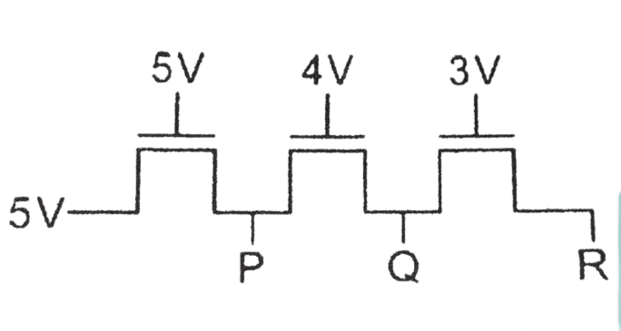

A)4V, 4V, 4V

B)4V, 3V, 2V

C)4V, 3V, 3V

D)5V, 4V, 3V

24) Which filter circuit offers constant gain in passband and attenuates frequencies beyond a certain limit?

a) Band-stop filter

b) High-pass filter

c) Low-pass filter

d) All-pass filter

25) Which of the following is a linear time-invariant system?

a) y(t) = t × x(t)

b) y(t) = x(t - 2) + x(t + 2)

c) y(t) = x²(t)

d) y(t) = sin(x(t))

26) A Schmitt trigger is primarily used to:

a) Amplify AC signals

b) Filter high-frequency noise

c) Convert a noisy input into a clean digital output

d) Perform analog integration

27) Depth of discharge of lithium ion battery is ____ and lead acid battery is ____

1. 100% , 80%
2. 90% , 100%
3. 50%, 50%
4. 100%,100%

28) A battery charger acts like a?

1. Convertor
2. Rectifier
3. Chopper
4. Cycloconverter

29)What is the type of battery is used in building of laptop?

1. Lead acid
2. Lithium ion
3. Nickel cadmium
4. Zinc silver oxide

30) Which electrolyte is used in Lead acid battery?

1. NaCl
2. Conc. NaOH
3. Conc. H2SO4
4. Dil. H2SO4